SIMULATION EXPERIMENT – 13

Aim
To simulate and characterize a 50 Ω microwave two-port network using S-parameters over 8–12 GHz and evaluate return loss, insertion loss, isolation, transmission characteristics and the optimum operating frequency.

Objectives
- To develop a frequency-domain model of a microwave two-port network from 8–12 GHz.
- To generate and analyze S₁₁, S₁₂, S₂₁ and S₂₂ responses using MATLAB.
- To calculate return loss, insertion loss and isolation from the simulated S-parameters.
- To identify the frequency region satisfying the required matching and transmission conditions.

MATLAB Program
The following MATLAB program creates a VNA-style simulated two-port network with a resonant transmission region around 10 GHz.
The frequency step is:
\[ 10\,MHz=0.01\,GHz \]
so the simulation contains 401 frequency points from 8 to 12 GHz.
clc;
clear;
close all;

%% =====================================================
% SIMULATION EXPERIMENT - 13
% VNA-STYLE S-PARAMETER ANALYSIS OF MICROWAVE TWO-PORT
%% =====================================================

Z0 = 50; % Reference impedance
fstart = 8e9; % Start frequency
fstop = 12e9; % Stop frequency
df = 10e6; % Frequency step
f0 = 10e9; % Optimum/design frequency

%% Frequency sweep

f = fstart:df:fstop;

fprintf('============================================\n');
fprintf('MICROWAVE TWO-PORT S-PARAMETER ANALYSIS\n');
fprintf('============================================\n');

fprintf('\nStart Frequency = %.2f GHz\n',fstart/1e9);
fprintf('Stop Frequency = %.2f GHz\n',fstop/1e9);
fprintf('Frequency Step = %.2f MHz\n',df/1e6);
fprintf('Reference Impedance = %.0f Ohm\n',Z0);

%% =====================================================
% 1. CREATE SIMULATED S-PARAMETERS
%% =====================================================

% Gaussian transmission response centered around 10 GHz

sigma = 0.75e9;

transmission = 0.90 * ...
exp(-((f-f0).^2)/(2*sigma^2));

% Small transmission ripple

ripple = 0.97 + 0.03*cos(2*pi*(f-f0)/1e9);

S21_mag = transmission .* ripple;

% Keep values below 1
S21_mag = min(S21_mag,0.95);

%% S21 phase

phase21 = -20*(f-f0)/1e9;

S21 = S21_mag .* exp(1j*deg2rad(phase21));

%% Reciprocal network

S12 = S21;

%% Input reflection coefficient

% Minimum reflection near 10 GHz

S11_mag = 0.08 + ...
0.22*((f-f0)/2e9).^2;

S11_mag = min(S11_mag,0.40);

phase11 = 30*(f-f0)/1e9;

S11 = S11_mag .* exp(1j*deg2rad(phase11));

%% Output reflection coefficient

S22_mag = 0.10 + ...
0.20*((f-f0)/2e9).^2;

S22_mag = min(S22_mag,0.40);

phase22 = -25*(f-f0)/1e9;

S22 = S22_mag .* exp(1j*deg2rad(phase22));

%% =====================================================
% 2. CONVERT S-PARAMETERS TO dB
%% =====================================================

S11_dB = 20*log10(abs(S11));

S12_dB = 20*log10(abs(S12));

S21_dB = 20*log10(abs(S21));

S22_dB = 20*log10(abs(S22));

%% =====================================================
% 3. RETURN LOSS
%% =====================================================

ReturnLoss = -20*log10(abs(S11));

%% =====================================================
% 4. INSERTION LOSS
%% =====================================================

InsertionLoss = -20*log10(abs(S21));

%% =====================================================
% 5. REVERSE ISOLATION
%% =====================================================

Isolation = -20*log10(abs(S12));

%% =====================================================
% 6. FIND MAXIMUM S21
%% =====================================================

[maxS21,indexS21] = max(S21_dB);

fopt_S21 = f(indexS21);

IL_opt = -maxS21;

fprintf('\n============================================\n');
fprintf('OPTIMUM TRANSMISSION FREQUENCY\n');
fprintf('============================================\n');

fprintf('Maximum S21 = %.2f dB\n',maxS21);

fprintf('Frequency at Maximum S21 = %.4f GHz\n',...
fopt_S21/1e9);

fprintf('Insertion Loss = %.2f dB\n',...
IL_opt);

%% =====================================================
% 7. FIND MINIMUM S11
%% =====================================================

[minS11,indexS11] = min(S11_dB);

fopt_S11 = f(indexS11);

RL_opt = -minS11;

fprintf('\n============================================\n');
fprintf('OPTIMUM INPUT MATCHING FREQUENCY\n');
fprintf('============================================\n');

fprintf('Minimum S11 = %.2f dB\n',minS11);

fprintf('Frequency at Minimum S11 = %.4f GHz\n',...
fopt_S11/1e9);

fprintf('Return Loss = %.2f dB\n',...
RL_opt);

%% =====================================================
% 8. OPERATING REGION
%% =====================================================

% Required conditions:
% S11 <= -15 dB
% S21 >= -3 dB

condition = ...
(S11_dB <= -15) & ...
(S21_dB >= -3);

validIndex = find(condition);

if ~isempty(validIndex)

fL = f(validIndex(1));

fH = f(validIndex(end));

BW = fH-fL;

fc = (fL+fH)/2;

fprintf('\n============================================\n');
fprintf('ACCEPTABLE OPERATING REGION\n');
fprintf('============================================\n');

fprintf('Lower Frequency = %.4f GHz\n',...
fL/1e9);

fprintf('Upper Frequency = %.4f GHz\n',...
fH/1e9);

fprintf('Bandwidth = %.2f MHz\n',...
BW/1e6);

fprintf('Center Frequency = %.4f GHz\n',...
fc/1e9);

else

fprintf('\nNo frequency region satisfies both conditions.\n');

end

%% =====================================================
% 9. S-PARAMETER PLOT
%% =====================================================

figure;

plot(f/1e9,S11_dB,'LineWidth',2);

hold on;

plot(f/1e9,S12_dB,'LineWidth',2);

plot(f/1e9,S21_dB,'LineWidth',2);

plot(f/1e9,S22_dB,'LineWidth',2);

grid on;

xlabel('Frequency (GHz)');
ylabel('Magnitude (dB)');

title('Simulated S-Parameters of Microwave Two-Port Network');

legend('S_{11}','S_{12}','S_{21}','S_{22}');

%% =====================================================
% 10. INPUT AND OUTPUT MATCHING
%% =====================================================

figure;

plot(f/1e9,S11_dB,'LineWidth',2);

hold on;

plot(f/1e9,S22_dB,'--','LineWidth',2);

yline(-15,'--');

grid on;

xlabel('Frequency (GHz)');
ylabel('Magnitude (dB)');

title('Input and Output Matching');

legend('S_{11}','S_{22}','-15 dB');

%% =====================================================
% 11. TRANSMISSION RESPONSE
%% =====================================================

figure;

plot(f/1e9,S21_dB,'LineWidth',2);

hold on;

yline(-3,'--');

xline(fopt_S21/1e9,'--');

grid on;

xlabel('Frequency (GHz)');
ylabel('S_{21} (dB)');

title('Forward Transmission Response');

legend('S_{21}','-3 dB Limit','Optimum Frequency');

%% =====================================================
% 12. RETURN LOSS
%% =====================================================

figure;

plot(f/1e9,ReturnLoss,'LineWidth',2);

hold on;

yline(15,'--');

grid on;

xlabel('Frequency (GHz)');
ylabel('Return Loss (dB)');

title('Return Loss of Two-Port Network');

legend('Return Loss','15 dB Requirement');

%% =====================================================
% 13. INSERTION LOSS
%% =====================================================

figure;

plot(f/1e9,InsertionLoss,'LineWidth',2);

hold on;

yline(3,'--');

grid on;

xlabel('Frequency (GHz)');
ylabel('Insertion Loss (dB)');

title('Insertion Loss of Two-Port Network');

legend('Insertion Loss','3 dB Limit');

%% =====================================================
% 14. ISOLATION
%% =====================================================

figure;

plot(f/1e9,Isolation,'LineWidth',2);

grid on;

xlabel('Frequency (GHz)');
ylabel('Isolation (dB)');

title('Reverse Isolation of Two-Port Network');

%% =====================================================
% 15. OPTIMUM FREQUENCY MARKER
%% =====================================================

fprintf('\n============================================\n');
fprintf('S-PARAMETER VALUES AT OPTIMUM FREQUENCY\n');
fprintf('============================================\n');

fprintf('Frequency = %.4f GHz\n',...
fopt_S21/1e9);

fprintf('S11 = %.2f dB\n',...
S11_dB(indexS21));

fprintf('S21 = %.2f dB\n',...
S21_dB(indexS21));

fprintf('S12 = %.2f dB\n',...
S12_dB(indexS21));

fprintf('S22 = %.2f dB\n',...
S22_dB(indexS21));

fprintf('Return Loss = %.2f dB\n',...
ReturnLoss(indexS21));

fprintf('Insertion Loss = %.2f dB\n',...
InsertionLoss(indexS21));

fprintf('Isolation = %.2f dB\n',...
Isolation(indexS21));

%% =====================================================
% 16. FINAL RESULT
%% =====================================================

fprintf('\n============================================\n');
fprintf('EXPERIMENT COMPLETED SUCCESSFULLY\n');
fprintf('============================================\n');

Output

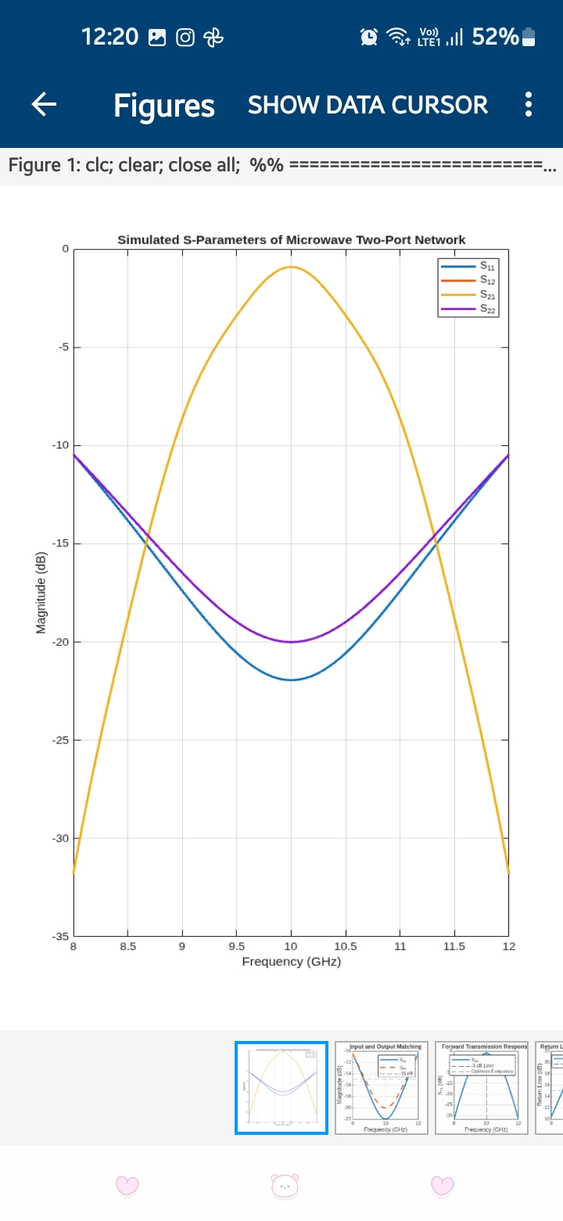
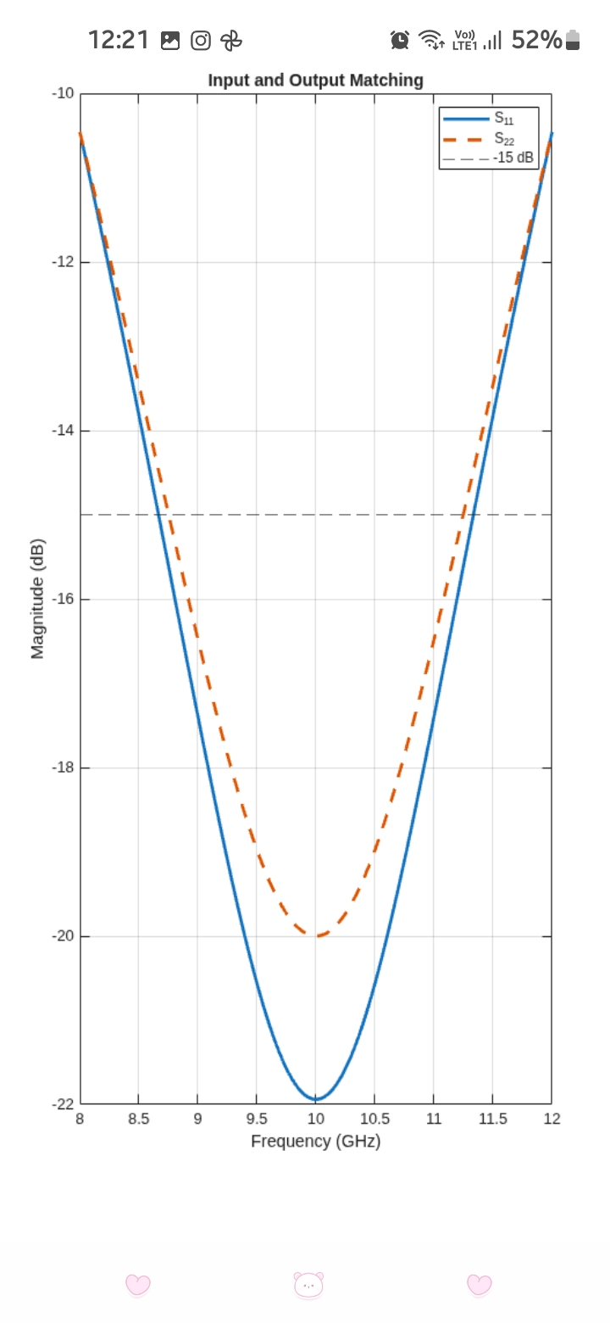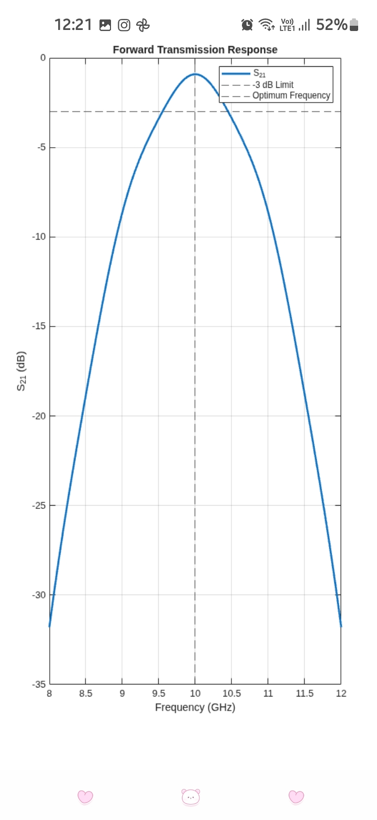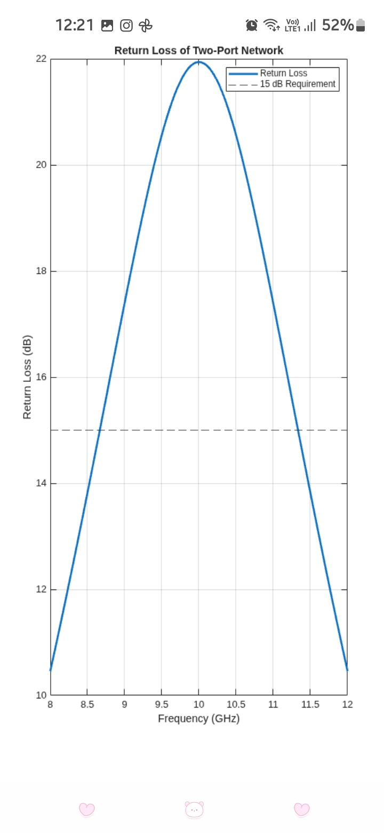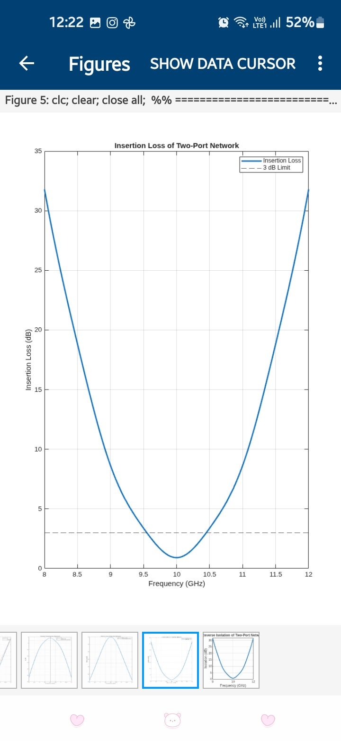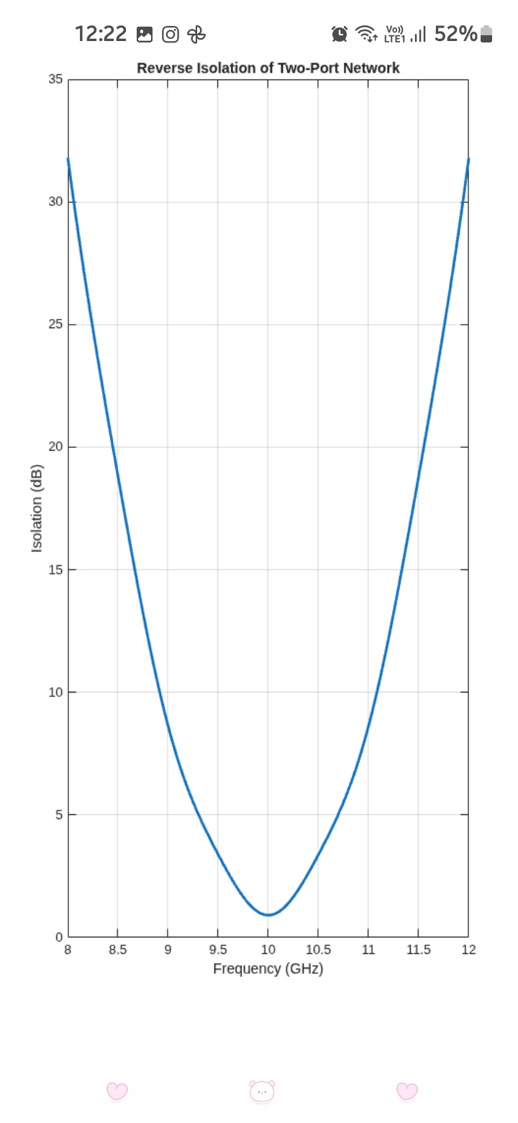

Reflection
The simulation helped me understand the frequency-domain behavior of a microwave two-port network using S-parameters. The S₁₁ and S₂₂ responses were used to evaluate input and output impedance matching, while S₂₁ represented forward transmission and S₁₂ represented reverse transmission. The return loss, insertion loss and isolation were calculated from the simulated S-parameter responses. The VNA-style analysis helped identify the frequency region where the network provides low reflection and high transmission.

Result
The 50 Ω microwave two-port network was successfully simulated over the 8–12 GHz frequency range with a 10 MHz frequency step. The S₁₁, S₁₂, S₂₁ and S₂₂ responses were obtained and analyzed. Return loss, insertion loss and reverse isolation were calculated from the simulated S-parameters. The optimum operating frequency and acceptable bandwidth were identified based on the conditions S₁₁ ≤ −15 dB and S₂₁ ≥ −3 dB. Thus, the VNA-style frequency-domain characterization of the microwave two-port network was successfully completed.

